Evolution: Son of Hermit
Sideboard Staff
The origins of this deck are a classic example of strategy evolution in Constructed Magic.
Son of Hermit's original predecessor is Trinity Green. Designed by the British division of the European Alliance, this deck was all the rage early in the Regionals/Nationals season. The concept of Trinity Green was to design a mono-green control deck with enough creature threats to take on ultra-aggressive weenie decks like Stompy, and enough disruption to slow down Replenish and control decks long enough for your creatures to claim the win.
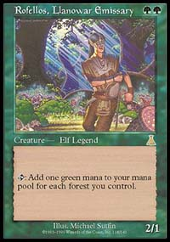
The deck featured a lot of mana acceleration (Llanowar Elves, Birds of Paradise, Rofellos, Llanowar Emissary, Gaea's Cradle) and some powerful spells capable of retarding an opponent's mana development (Plow Under, Fallow Earth, Tangle Wire). The deck would often get draws that would allow for Plow Under to be cast by turn three, crippling an opponent. Its creature base featured the powerful Deranged Hermits and Skyshroud Poachers. Often you could search for a Hermit at the end of your opponent's turn, pay echo with Cradle or other fast mana and summon a second Hermit in your attack step to make the Squirrels 3/3.
Although Trinity was an extremely powerful deck, the metagame has adjusted itself to where most other tier 1 decks could beat it. Replenish decks armed themselves with Frantic Search and Grim Monolith to fight the land destruction strategy. Red Deck Wins made its appearance, able to easily destroy green's early mana creatures and thus hold them off from casting the more powerful spells long enough to win. Control Black became popular even though it could hardly beat any deck without Forests in it.
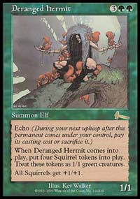
These factors contributed to Trinity getting crushed at the U.S. Nationals. I was one of those unfortunate enough to play Trinity there and my record was dismal. I even lost to Mike Flores! Don't tell anyone please.
Despite Trinity getting its behind handed to it at U.S. Nationals, a very similar deck had an excellent performance, placing two of its players into the top 8. The deck was designed by Aaron Forsythe and his playtest group and became known as Angry Hermit. This deck was originally built for Regionals last year. Aaron saw Trinity Green's success this season and dusted off his G/r strategy.
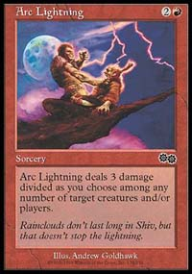
An Angry Hermit staple
Angry Hermit lacks some of the raw power of Trinity Green, but it is more versatile. The maindeck additions are Avalache Riders and Arc Lightning. Riders are an effective turn 4 disruption card that also deals damage, or blocks another creature. Arc Lightning is amazing in the matchup against Trinity Green or most other creature decks. Adding red also expanded the deck's sideboard options, allowing it to play cards like Boil.
After the U.S. Nationals, Angry Hermit became a staple tier 1 deck almost overnight. It claimed many top spots in Latin American and APAC continental championships. People were forced to modify their sideboards again, and that allowed Trinity Green to become tier 1 again and do well at European Championship.
In testing for the World Championship, at least two teams made the leap from Angry Hermit to No Hermit independently of each other. On European Alliance, it was Dirk Baberowski who first examined this strategy. On Mogg Squad, it was Gary Wise.
Squirrel killer
Several weeks prior to Worlds, the two teams discovered that they were working on almost identical decks. Mogg Squad and European Alliance made a pact to work together for the Standard portion of the event. The deck performed well. Although no members of these two teams made top 8, Dominik Hothow did playing an EA variant. Zvi Mowshowitz of Mogg Squad finished in the top 16 and many others who played Son of Hermit finished in the money.
The concept of this deck is rather simple. It keeps most of the Angry Hermit deck structure... except the Hermits! Many deck's sideboard cards like Earthquake, Cave-In or even Tremor to defeat Trinity and Angry Hermit strategies. We've chosen to substitute the "win" cards for something that is not hampered by these removal spells. Out went Hermits and Poachers, replaced by Blastoderms and our own Earthquakes to improve the matchup against both aggressive strategies and our own deck's predecessors.
This strategy offers an amazing array of options and we kept tuning it till the very last day before Worlds to make a perfect version. I played the following configuration of the deck, and stand by that configuration to this day.
Alex Shvartsman, Worlds 2000
Son of Hermit
Main Deck |  | Sideboard
4 Birds of Paradise  4 Llanowar Elves  1 Rofellos, Llanowar Emissary  1 Vine Trellis  3 Yavimaya Elder  4 Blastoderm  2 Masticore  4 Avalanche Riders | 1 Crop Rotation  1 Worldly Tutor  4 Arc Lightning  3 Earthquake  4 Plow Under  11 Forest  2 Mountain  4 Rishadan Port  4 Karplusan Forest  1 Dust Bowl  1 Gaea's Cradle  1 Treetop Village | 4 Uktabi Orangutan  1 Masticore  1 Yavimaya Elder  1 Earthquake  3 Boil  3 Tectonic Break  2 Creeping Mold

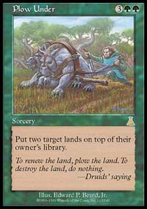

Ideally you want to spend your first two turns developing your mana base - playing Elves and Birds mostly. On the third turn you want to be casting an Avalanche Rider or Plow Under (though Blastoderm will do nicely as well). You generally do not want to cast Masticore early at all.
Against aggressive decks Son of Hermit becomes much more controlling. You want to play taking as little damage as possible, especially against red, since there is no life gain in the deck. Against most aggressive decks, your job is hold off their forces long enough to develop 8+ mana on the table, then play Masticore.
Here is how the sideboard works:
Playing against Stompy
-4 Plow Under +1 Masticore +1 Earthquake +2 Uktabi Orangutan
Plow Under is good in every matchup, but it is generally a little slow and expensive to keep against aggressive decks. Extra Masticore and Earthquake are self explanatory, while Uktabi Orangutans are brought in because an opponent might be sideboarding in artifacts of their own, such as Cursed Totem.
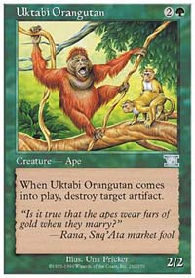
Everyone loves a monkey
Playing against Red Deck Wins or Ponza
-4 Plow Under +1 Masticore +1 Yavimaya Elder +2 Uktabi Orangutan
You want to board in an extra Yavimaya Elder against any deck that might have enough firepower to kill your mana creatures early on. Elder does not only provide card economy, it also helps you make sure to get your red mana - which is ever more important against aggressive decks.
Playing against Replenish
Game 1 is relatively even, or perhaps slightly in their favor. You have a solid advantage after the sideboard though.
-4 Arc Lightning -3 Earthquake -1 Vine Trellis -2 Masticore +3 Boil +2 Creeping Mold +3 Tectonic Break +2 Uktabi Orangutan
This very heavy sideboard assures that every card you draw other than a mana source is capable of disrupting Replenish's strategy as well as sometimes dealing damage to them.
Playing against Accelerated Blue
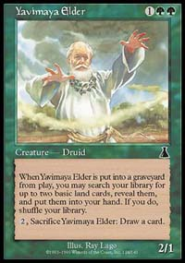
Handle with care
This matchup is not favorable. Game 1 is almost a lost cause and while you make things even after the Sideboard, an experienced Acc.Blue player should be able to win this matchup. Still, its pretty close to 50-50.
-4 Arc Lightning -3 Earthquake -2 Masticore -1 Worldly Tutor -1 Crop Rotation +3 Boil +1 Elder +4 Uktabi Orangutan +3 Creeping Mold/Tectonic Break
The key to winning this matchup is to force enough countermagic out of your opponent's hand to sneak through a devastating Boil. Also be very careful not to allow your Yavimaya Elders to get stolen by Treachery - they would be extremely dangerous on the other side of the table. If you have to tap out next turn, use the Elder's ability to sacrifice it.
Playing against Tinker
This is by far the worst matchup. Game 1 is almost unwinnable and while you have a solid fighting chance after the sideboard, winning two in a row against this deck is quite difficult.
-3 Arc Lightning -2 Masticore -4 Plow Under +4 Uktabi Orangutan +3 Boil +2 Creeping Mold
In this matchup you are forced to keep some of the direct damage in order to kill an early Metalworker. Occasionally you might also be able to take out their Masticore, or cast a large enough Earthquake to kill an opponent after he paid too much life for a Processor. Plow Under is a little too slow for the matchup, you'd rather be attacking their artifacts. It is replaced by Boil, which is cheaper and can destroy on average half of the lands they have in play.
Playing against Trinity or Angry Hermit
-1 Llanowar Elf, -1 Yavimaya Elder +1 Earthquake +1 Masticore
This matchup is generally in your favor. You can tell that by the fact that there is no card you really want to sideboard out against them. Extra Masticore and Earthquake are useful enough to replace some of the other creatures, but cutting an Elf or a Vine Trellis is a risky sacrifice since the player able to get to 5 mana and start casting Plow Unders first often wins. Still, 4 Arc Lightnings and 4 Earthquakes should allow you to get enough of an advantage in the early game - especially against the monogreen Trinity.
Tips and Tricks:
- Use Worldly Tutor sparingly. You will need it against an aggressive decks to find a Masticore by the time you need it, or find a Blastoderm to finish an opponent off. Drawing it on the first turn against control decks, you might consider tutoring for a Rofellos.
- Crop Rotation is at its best against decks with land destruction cards in them like Ponza, RDW or Angry Hermit. In response to them targeting one of your lands, sacrifice it to get another land. While you are still trading card for card, they are failing at trying to stunt your mana development.
- Against other strategies Crop Rotation is still very good. You can use it for a surprise attack with a Treetop Village or to generate more mana with Gaea's Cradle. Most commonly you will want to get a Dust Bowl with it and blow up several of their lands.
- Masticore's upkeep is not as painful in a deck with Yavimaya Elders. Even when you have no other cards in hand you can play an Elder, on your next turn put Masticore's upkeep on the stack and sacrifice an Elder in response to put three more cards into your hand.
- Many players misplay the Elder's ability. If you sacrifice this creature, you must search your deck for two lands BEFORE drawing a card. If you draw a card first, you've basically searched for zero lands and can no longer try to get them out of your library.
- Pay close attention to whether or not Avalanche Riders' echo is to be paid. Most of the time, you just want to let it go, but there are definitely situations where you want to pay to keep it around.
- Use Earthquake aggressively to help your Blastoderm get through. The deck's greatest weakness is its lack of actual damage sources. While there is certainly enough to win games, you do not want to waste 5 points of Blastoderm beatdown if you do not have to.

